Family Now 3.5

UNISYS

Detailed Design- Maltreatment in Care DB

Version 1.0 Status: Approved

27 07 2017

Unisys Confidential

This document is confidential and proprietary to Unisys Corporation. It is not to be used, reproduced, or disclosed outside Unisys without the written consent of Unisys Corporation. The information in this document is furnished for use by Unisys support personnel in servicing customer’s equipment, or by a customer under a license agreement with Unisys.

Document Revision History

|  |  |  |  |  |  |  |
| --- | --- | --- | --- | --- | --- | --- |
| Date | Version | Section Changed | Change Description | Author | Reviewer | Approver |
| 20 JULY 2017 | 0.1 | All | Change the flow | Vibhav Dwivedi | Mark |  |
| 27 JULY 2017 | 1.0 | All | New Document | Vibhav Dwivedi | Mark |  |

**User Story #50: Maltreatment in Care DB**

**USER STORY:** Technical Story - Need to add database fields for Maltreatment in Care fields on Add Participants screen.

**1. Screen 1: CPS –Maltreatment**

* 1. **STATIC CONTENT:**
* App Name (Logo): Family Now
* Visual screen elements
* Screen Title: Maltreatment
* Trigger action: Login to Core application
  1. **SCREEN SHOT**

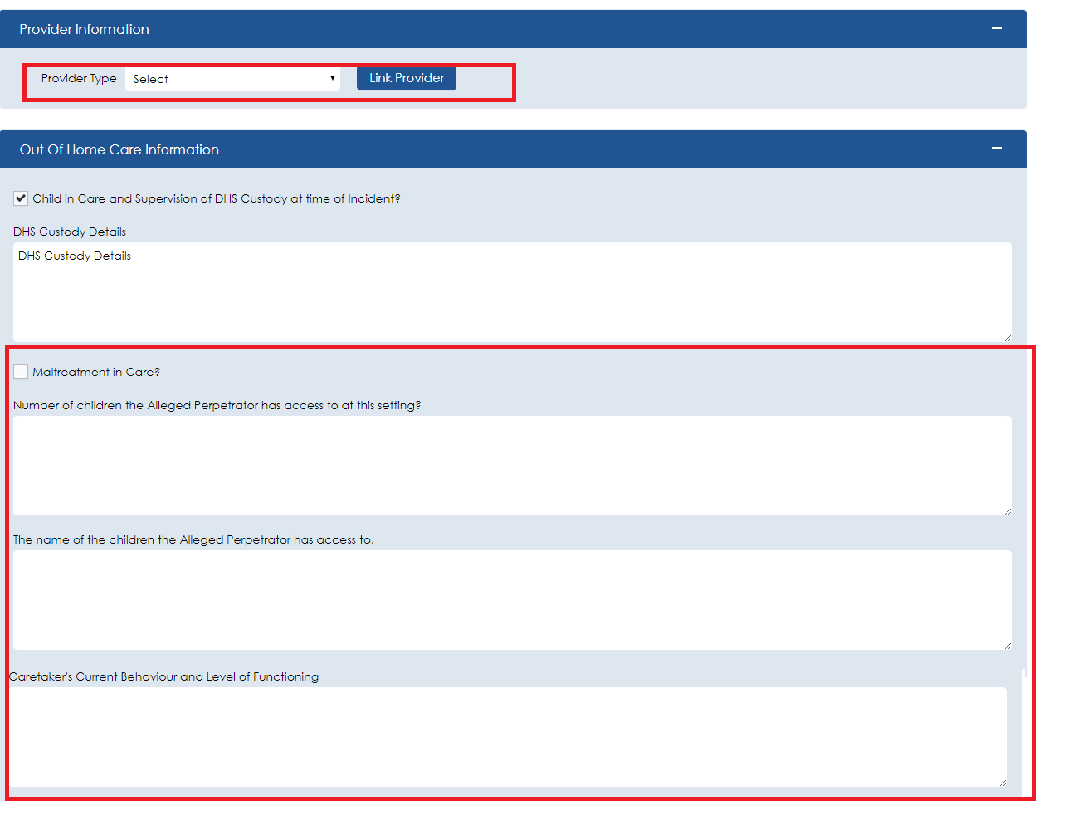

**1.4 ACCEPTANCE CRITERIA**

|  |  |  |  |
| --- | --- | --- | --- |
| # | UC/Screen/BR | Requirement | Status |
| 1 | Add Participant Screen | Remove the Provider Information expando section on the Add Participant screen. | Draft |
| 2 | Add Participant Screen | Remove the following fields from the Out of Home Care Information expando section:   * Maltreatment in Care? (Checkbox) * Number of children the Alleged Perpetrator has access to at this setting? * The name of the children the Alleged Perpetrator has access to. * Caretaker’s Current Behavior and Level of Functioning. | Draft |
| 3 | Maltreatments Page (Under CPS Intake) | Add a new expando section called ‘Maltreatment in Care’. In this new expand section add all the fields that were removed from the Add Participants screen. | Draft |
| 4 | Maltreatments Page | The Link Provider button should be moved below Provider Type field and space provided to show Provider Name, Address and Contact Information after a successful linking of a provider. | Draft |
| 5 | Maltreatments Page | The ‘Number of children the Alleged Perpetrator has access to at this setting?’ should be a text field that holds no more than 3 chracters. | Draft |
| 6 | Maltreatments Page | The database attribute for Provider Type should be set to INTAKE.thirdPartyTypeCode. The data to populate the drop down comes from Domain_Code = ‘ThirdPartyType’ | Draft |
| 7 | Maltreatments Page | The attribute for the Maltreatment in Care? Checkbox is INTAKE.thirdPartyInvolvedFlag. | Draft |
| 8 | Maltreatments Page | The attribute for ‘Number of children the Alleged Perpetrator has access to at this setting?’ is INTAKEOHC.apAccessToChildCount. | Draft |
| 9 | Maltreatments Page | The attribute for ‘The name of the children the Alleged Perpetrator has access to.’ is INTAKEOHC.apAccessToChildNames | Draft |
| 10 | Maltreatments Page | The attribute for ‘Caretaker’s Current Behavior and Level of Functioning’ is INTAKEOHC.ctCurBehavAndFuncLevel | Draft |